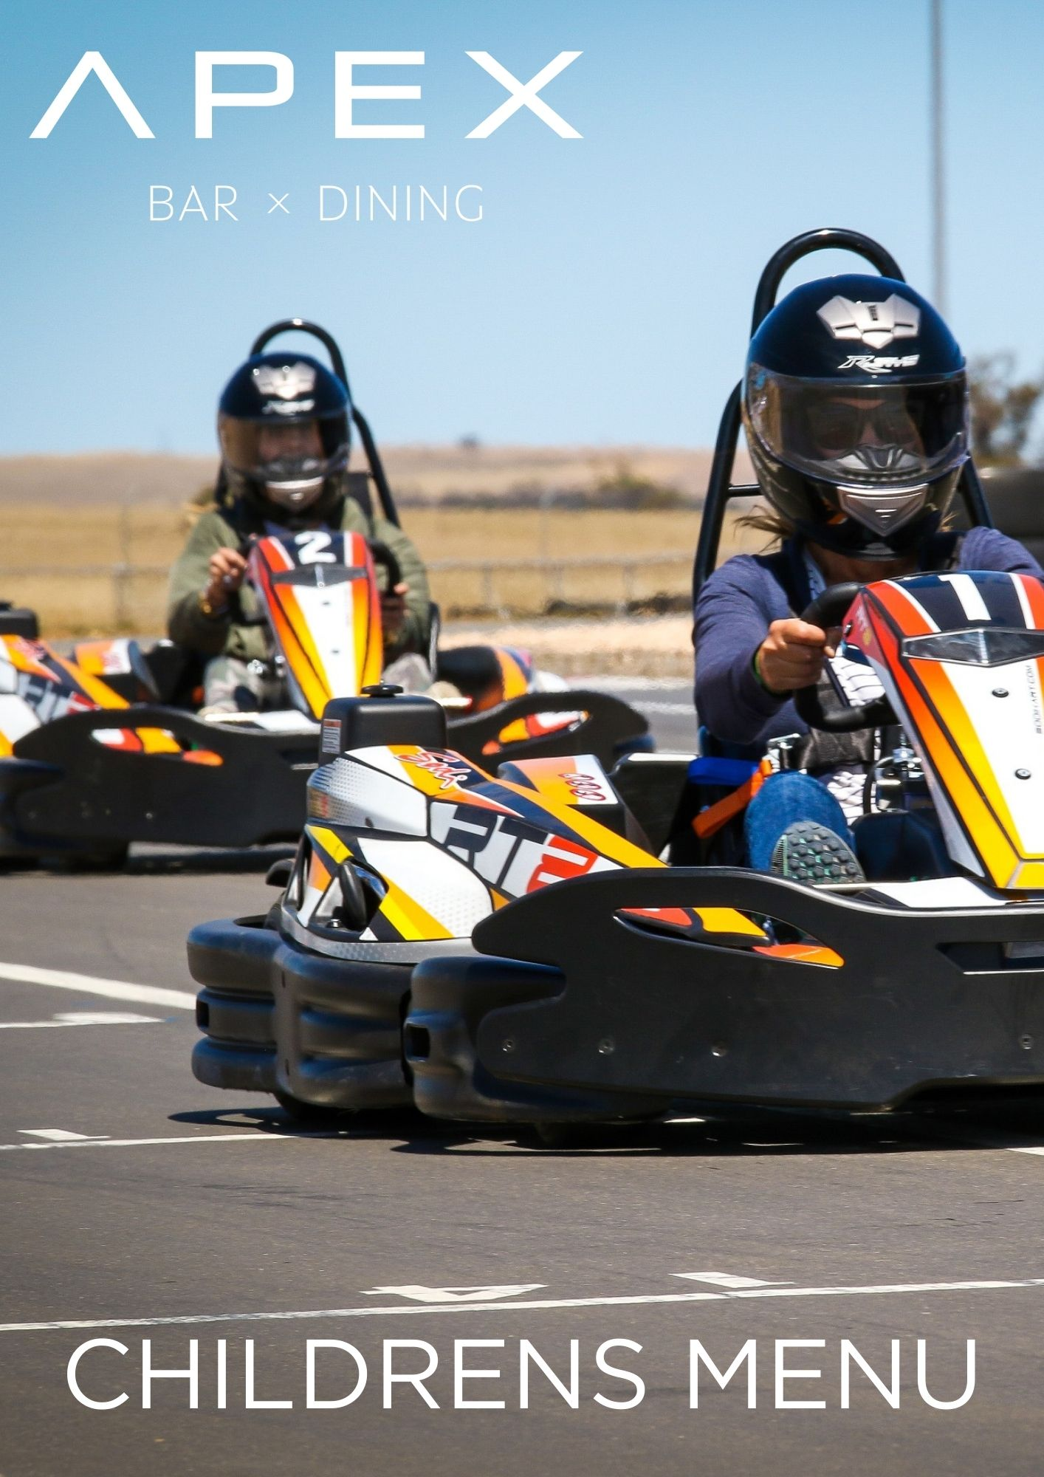

CHILDREN’S MENU
Napoli Pasta 12
Napoli sauce, cheese

Chicken Nuggets 12
Chips, tomato sauce

Cheeseburger 12
Chips

Crumbed Fish 12
Chips, tomato sauce

Kids Ice Cream with topping 7
Chocolate | Strawberry | Caramel

